Exploratory Data Analysis (EDA) Report – McDonald’s Sales Performance Analysis

Introduction
This project focuses on performing Exploratory Data Analysis (EDA) on McDonald’s sales dataset consisting of menu items and order transactions. The dataset captures menu details and customer orders at McDonald’s outlets.
The objective of this analysis is to extract meaningful insights related to sales performance, item popularity, category contribution, customer preferences, and time-based trends, and to build interactive dashboards that support business decision-making.
Data Modelling: Note: This is the outcome after data processing
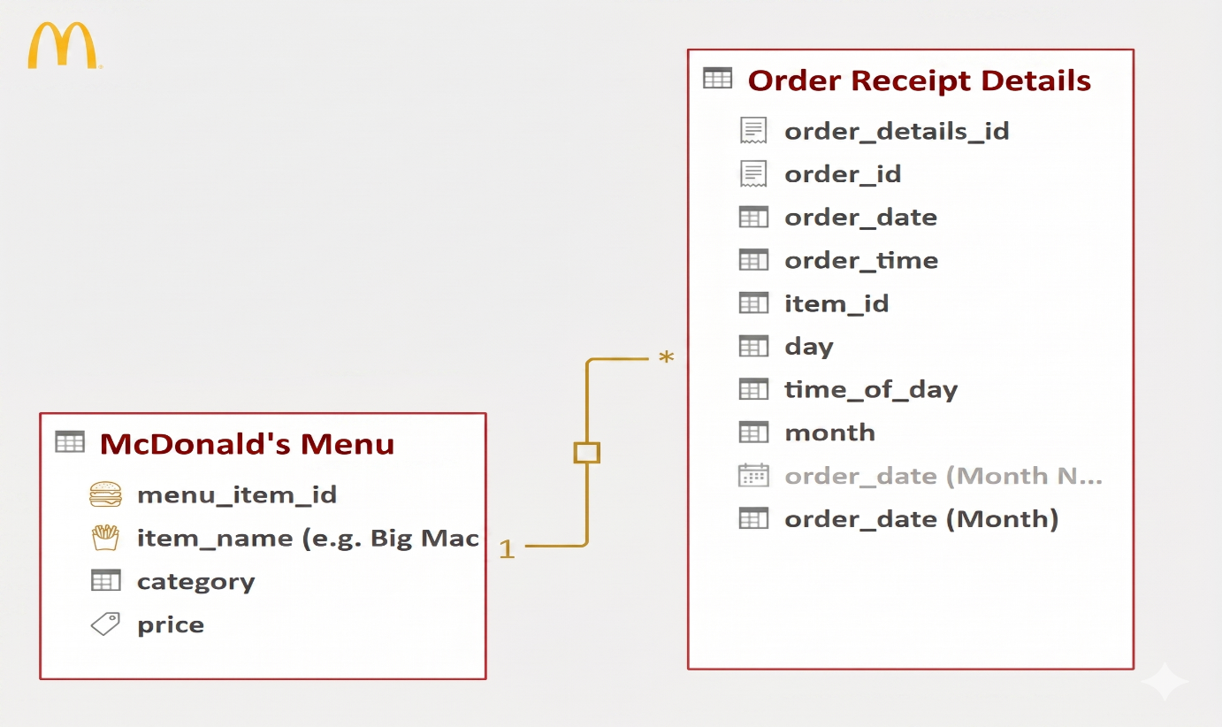

Objectives of Analysis

The primary goals of this project are to analyze and understand:
- Total sales revenue and revenue by category
- Total number of orders and average order value
- Most and least popular menu items
- Category-wise performance and contribution
- Sales trends by day, month, and time of day
- Weekday vs Weekend ordering patterns
- Average number of items per order
- Peak hours and time-based trends
- Top 5 performing menu items
- Revenue distribution across product lines

Additionally, dashboards will be designed for:
- Category and Product Performance Analysis
- Time-based and Hourly Sales Trends
- Menu Engineering and Item Popularity

Dataset Description The dataset consists of two interconnected tables:
The Menu_List table contains 32 records with 4 attributes, including menu_item_id, item_name, category (product line), and price.
The Order_Details table contains 999+ records with 5 attributes, capturing transaction-level details such as order_details_id, order_id, order_date, order_time, and item_id.

Data Relationships The dataset follows a simple relational structure:
- Orders are linked to Menu items using item_id = menu_item_id
- This structure enables multi-level analysis across orders, items, categories, and time dimensions.

Initial Exploratory Data Analysis (EDA) During the initial exploration, the following checks were performed:
- Understanding the structure and size of each table
- Identifying missing or null values
- Checking for duplicate records
- Verifying data consistency across relationships
- Reviewing data types for each column

Key observations:
- The Menu_List table is clean with 32 unique menu items
- The Order_Details table contains the highest granularity of transactional data
- Date and time fields are crucial for temporal analysis
- No quantity column exists (each ordered item is treated as 1 unit)
- Some trailing empty rows were present in Menu_List

Data Cleaning (Using Power Query) The dataset is cleaned using Power Query with the following steps:
- Promoted first row as headers
- Removed empty rows (kept only top 32 rows in Menu_List)
- Renamed category to product_line
- Changed proper data types (Date, Time, Decimal Number)
- Created calculated columns (e.g., revenue = price × 1, day_of_week, hour_of_day, is_weekend)
- Standardized column names and removed unnecessary fields

ETL Process
The ETL process followed in this project includes: Extract: Data is collected from the provided Excel tables. Transform: Data is cleaned, formatted, and enriched using Power Query. New time-based columns and revenue calculations are added. Load: The transformed data is loaded into Power Pivot for data modeling and further analysis.

Data Modeling (Power Pivot) A relational data model is created using Power Pivot:
- One-to-many relationship is established between Order_Details and Menu_List on item_id = menu_item_id
- Fact Table: Order_Details
- Dimension Table: Menu_List

Key calculated measures include:
- Total Revenue
- Total Orders
- Average Order Value (AOV)
- Items per Order
- Revenue by Product Line
This model enables efficient and dynamic analysis across menu items, categories, and time dimensions.
Dashboard Development Three dashboards will be created to visualize insights:
Sales Overview Dashboard This dashboard provides overall performance metrics. Key metrics: Total Revenue, Total Orders, AOV, Items per Order. Visuals include: KPI cards, Revenue by Product Line (Bar Chart), Top 10 Items (Bar Chart), Monthly Sales Trend (Line Chart).
Time & Trend Analysis Dashboard This dashboard focuses on temporal patterns. Key metrics: Hourly sales, Weekday vs Weekend comparison, Peak hours. Visuals include: Hourly Order Volume (Column Chart), Heatmap by Hour & Day, Sales Trend Over Time.
Menu & Category Performance Dashboard This dashboard analyzes item and category performance. Key metrics: Revenue by Category, Top/Bottom Items, Menu Engineering. Visuals include: Category Contribution (Donut/Pie), Top 5 Items Comparison, Popularity vs Revenue Scatter Plot.

Limitations of Dataset The dataset lacks several important attributes such as:
- Quantity ordered (multiple units per item)
- Store/Outlet location
- Customer demographics or order type (dine-in, takeaway, delivery)
- Discounts or promotions
- Actual profit margin per item
The inclusion of these attributes would significantly improve analysis in areas such as profitability, customer segmentation, and store-wise performance.

DASHBOARD:
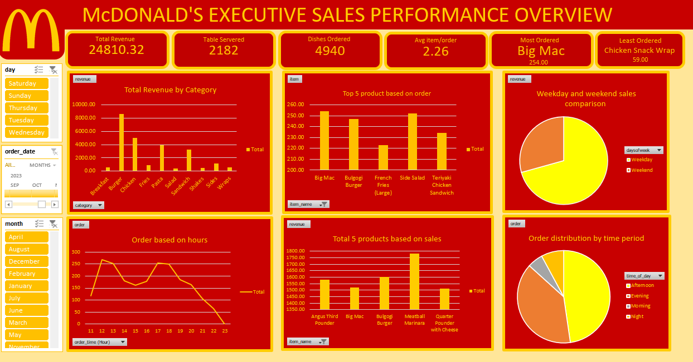
Conclusion This project demonstrates how structured sales data can be transformed into meaningful insights using EDA, data cleaning in Power Query, and relational modeling in Power Pivot. The upcoming dashboards will provide a clear understanding of McDonald’s menu performance, sales trends, and customer preferences, enabling better decision-making for menu optimization, staffing, and promotional strategies.

